Assignment 27.
- What is Filed symbol ? types of field symbols?
- A Field Symbol is like a pointer/alias that points to an existing memory location - it does NOT have its own memory.
- A Field Symbol is a symbolic name (pointer) that refers to the memory location of another variable.
- Syntax: FIELD-SYMBOLS: <fs> TYPE datatype.
- Example:
- 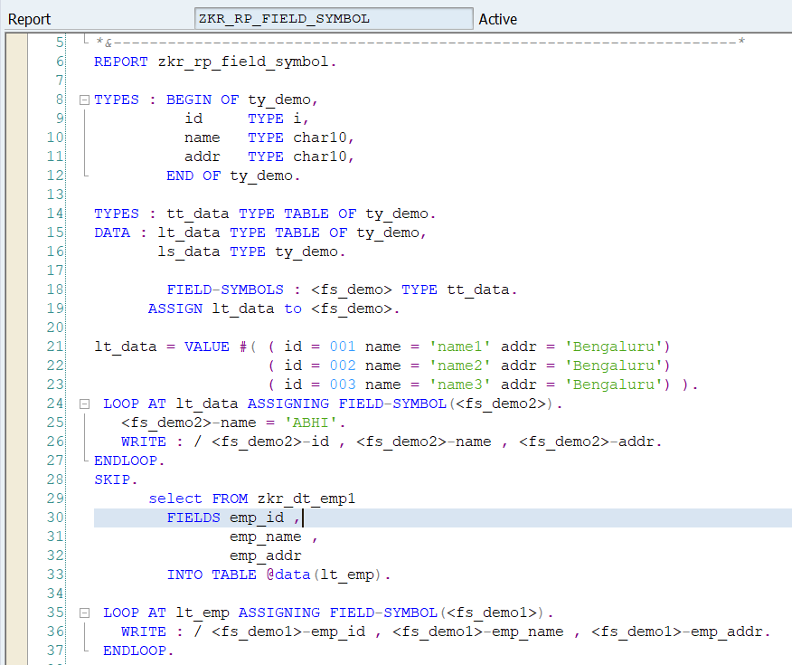

- Output:
- 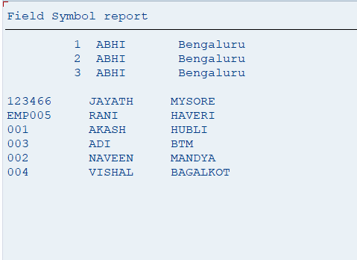
- Types:
- 1. Typed Field Symbol: Defined with a specific data type.
- FIELD-SYMBOLS: <fs> TYPE i.
- 2. Generic Field Symbol: No specific type defined.
- FIELD-SYMBOLS: <fs> TYPE ANY.
- Difference Between Work Area and Field Symbol.
- Work Area:
- A work area is a data object (structure) that temporarily holds a copy of a row from an internal table.
- Field Symbol:
- A field symbol is a pointer (reference) that directly points to the memory location of data without copying it.

Feature | Work Area | Field Symbol
Nature | Data container | Pointer (reference)
Data Handling | Holds a copy of data | Points to original data
Memory Usage | More (data duplication) | Less (no duplication)
Performance | Slower (copy operation) | Faster (direct access)
Modification | Changes not reflected automatically | Changes directly affect original data
Declaration | DATA: wa TYPE ... | FIELD-SYMBOLS: <fs> TYPE ...
Usage | Used with INTO | Used with ASSIGNING

- Work Area:
- Easy to understand
- Safer for beginners
- Field Symbol:
- Faster performance
- Less memory usage
- Direct data manipulation
- A work area stores a copy of a record from an internal table, whereas a field symbol directly points to the original data in memory, making it more efficient in terms of performance and memory usage.
- Fetch 100 records from mara and change material type 'FERT' to 'FT' and 'SERV ' to 'SE' and display them in table format (Don’t use work area in program use typed field symbols).
- Used FIELD_SYMBOL only.

- 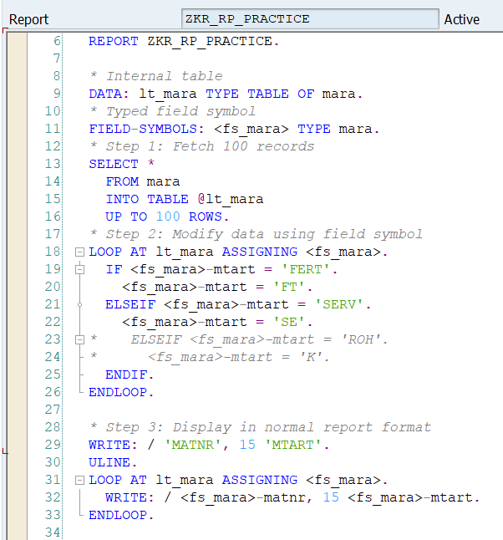
- Output:
- 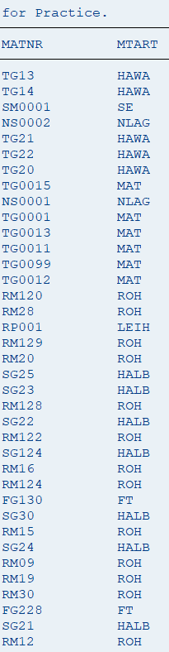
- Fetch 100 records from sales order header and change sales doc to '0000000001' for seles doc '0000018341' and '0000018345' and display them in table formate (Dont use work area in program use typed field symbols).
- 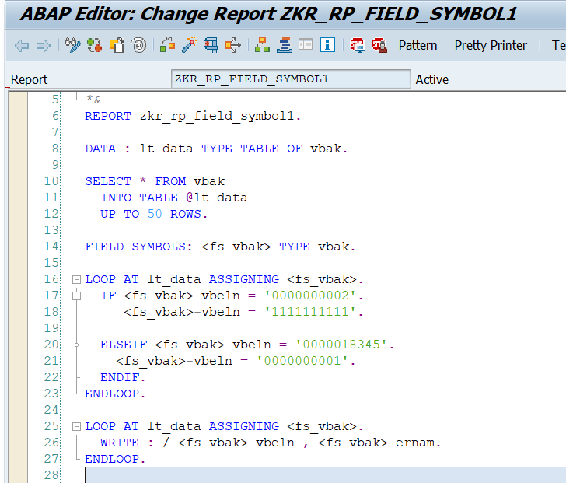
- Output:
- 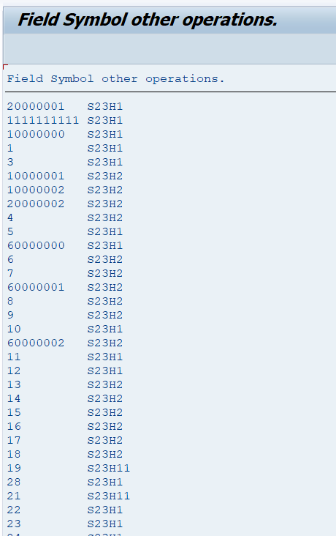
- Use Parallel curser with field symbol
- 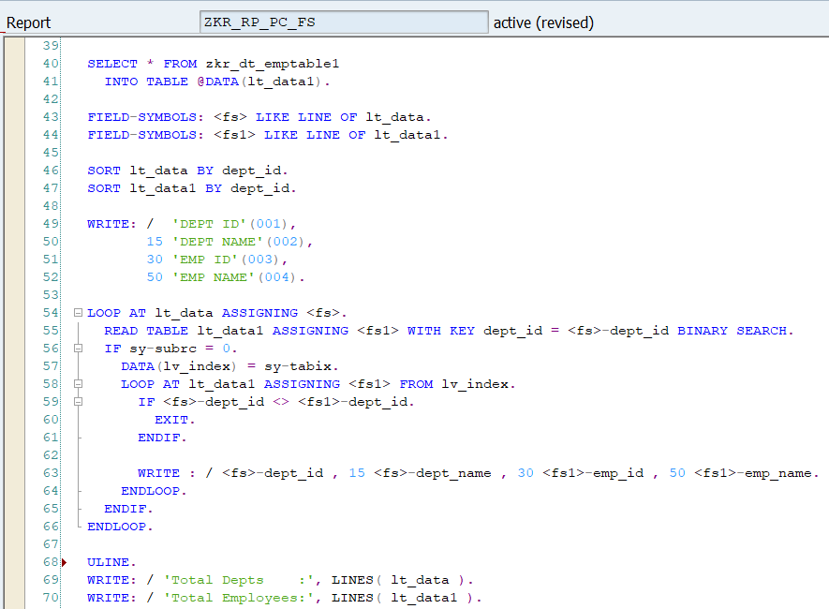
- Output:
- 